BCCTaipei Better Business Awards
UK Alumni Association of the Year – ESG & UK Education Impact Award
2025 Guidance and Criteria

Please provide any supporting documents as separate attachments when you send this application in.
Please answer the criteria in the space provided in English or Chinese
Company Name (English/Chinese):
Company Website:
Contact Person:
▪ Name:
▪ Email:
▪ Phone Number:
Judging Criteria
1. Commitment to ESG and UK Education Values
Describe how your association integrates ESG principles and UK education values into its mission and activities. Explain how these values shape your decisions, partnerships, and programming.
(Limit to 600 words)
2. Innovative Programmes or Initiatives
Share at least two impactful initiatives or events launched in the past year. Describe the goals, target audience, execution, and results. Highlight creativity, relevance to ESG or education, and the difference these made in your community or network.
(Limit to 1000 words)
3. Member and Community Engagement
Explain how you keep your alumni members actively engaged and how you reach out to external communities. Describe efforts to build inclusion, strengthen networks, or support educational/civic initiatives.
(Limit to 500 words)
4. Collaboration and Partnerships
Outline any partnerships with UK institutions, local schools, NGOs, or other groups. Explain how collaboration strengthens your mission and helps you achieve wider impact.
(Limit to 500 words)
5. Evidence of Impact
Provide both qualitative and quantitative data that demonstrate your association’s influence. This could include participant feedback, social media reach, follow-up actions, testimonials, or real-world results.
(Limit to 1000 words)
6. Programme Summary Slide
Please submit a one-page PowerPoint slide summarising your key activities, objectives, and ESG or UK education focus. This will be used for presentation and judging purposes.
(See template provided)
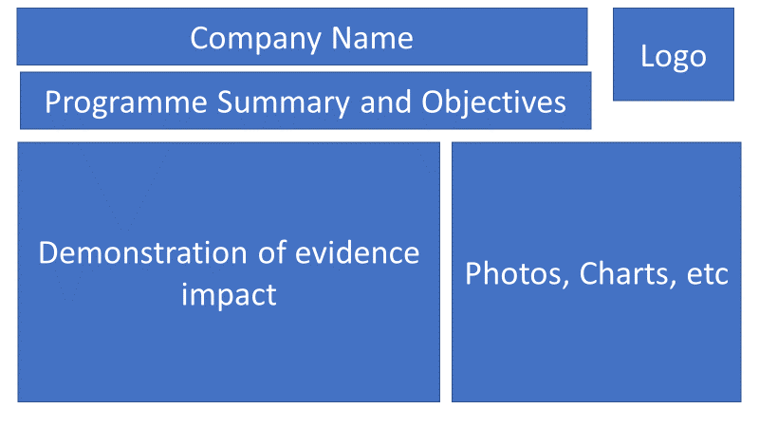

Why the UK Alumni Association of the Year – ESG & UK Education Impact Award?
The UK Alumni Association of the Year – ESG & UK Education Impact Award celebrates an alumni association in Taiwan that has demonstrated outstanding leadership in promoting both the core values of UK education and Environmental, Social, and Governance (ESG) principles.
UK education is recognised worldwide for its emphasis on critical thinking, global citizenship, inclusivity, and innovation. This award honours alumni associations that embody these ideals — delivering meaningful impact through events, outreach, and advocacy that advance sustainability, diversity, well-being, and cross-cultural understanding.
We are looking for associations that:
- Promote the value and relevance of UK education
- Provide platforms for continuous learning and collaboration among their alumni networks
- Demonstrate leadership through service, engagement, and ESG-aligned initiatives
- Form partnerships that expand their impact across communities or industries
This year’s award is proudly sponsored by
TutorABC
TutorABC is a global online education provider specializing in English and Chinese learning. With over 20 years of experience, the platform has served more than 100 million learners across 100 countries, supported by a network of 35,000 certified teachers and trusted by over 3,000 enterprise clients worldwide. Its AI-powered platform features tools like ChatAI and interactive roleplays, enabling immersive and personalized learning experiences. TutorABC also offers study abroad consulting and corporate training services adopted by a wide range of multinational enterprises across various industries. Through a blend of advanced technology and expert human instruction, TutorABC empowers lifelong learners and global professionals to succeed in an increasingly connected world.
British Council.
The British Council is the UK’s international organisation for cultural relations and educational opportunities. We support peace and prosperity by building connections, understanding and trust between people in the UK and countries worldwide. We do this through our work in arts and culture, education and the English language. We work with people in over 200 countries and territories and are on the ground in more than 100 countries. In 2024–25 we reached 599 million people. We work directly with individuals to help them gain the skills, confidence and connections to transform their lives and shape a better world in partnership with the UK. We support them to build networks and explore creative ideas, to learn English, to get a high-quality education and to gain internationally recognised qualifications.
The Icons
The Icons is a London-headquartered global leadership media platform, dedicated to profiling the world’s most influential leaders, industry pioneers, and visionary thinkers. With a presence across key international markets, The Icons delivers in-depth interviews, signature features, and exclusive events that spotlight transformative leadership, sustainability, and lasting impact. Through strategic storytelling and sharp perspectives, The Icons not only captures their vision—but also empowers these changemakers to amplify their influence, enhance stakeholder engagement, and drive global conversations.

Their sponsorship reflects the spirit of this award — elevating the role of alumni in shaping a more connected, inclusive, and sustainable future through education.
The award offers a platform to spotlight the power of UK alumni communities in building a better society. The winner will be recognised by BCCTaipei and featured across our platforms as a leading example of alumni-driven social impact and engagement.
We welcome applications from UK alumni associations of all sizes based in Taiwan — from long-established groups to new, grassroots communities. Creativity, authenticity, and purpose-driven impact are what matter most.

Judging Process
Companies will be evaluated based on their performance, including any ongoing projects in Taiwan. The content of the submission and evidence should cover activities that have taken place within the 24 months preceding the award deadline.
Submissions must demonstrate:
- Integration of ESG and UK education values into programming
- Positive impact on members and the broader community
How to Submit
Please send your completed application and supporting materials to BBAMarketing@bcctaipei.com by Sunday, 17 August 2025.
Submissions may include hyperlinks to internal or external websites (within the word limit).

