BCCTaipei Better Business Awards
Sustainable Finance Excellence Award
2026 Guidance and Criteria

Please provide any supporting documents as separate attachments when you send this application in.
Please answer the criteria in the space provided in English or Chinese
Company Name (English/Chinese):
Company Website:
Contact Person:
▪ Name:
▪ Email:
▪ Phone Number:
Judging Criteria
1. Strategic Integration
Explain how sustainability and sustainable finance considerations are incorporated into your organisation’s business strategy, client solutions, financing or investment approaches, or future growth plans.
(Limit to 600 words)
2. Sustainable Innovation
Highlight innovative sustainability-related initiatives, products, services, financing solutions, partnerships, or business practices implemented by your organisation.
Applications should demonstrate originality and scalability in advancing sustainable business practices through innovative, financing solutions, strategic collaboration, or operational transformation.
(Limit to 800 words)
3. Quantifiable Environmental & Social Impact
Demonstrate the measurable environmental and/or social impact achieved through your organisation’s sustainability initiatives, products, services, or financing activities, including tangible outcomes such as carbon reduction, environmental benefits, and/or social impact.
(Limit to 800 words)
4. Governance & Risk Stewardship
Outline how your organisation promotes robust governance, accountability, transparency, and ethical compliance in support of sustainability-related objectives.
Applications should demonstrate how risk oversight, internal controls, and responsible business practices are embedded to support long-term organisational resilience and sustainable growth.
(Limit to 600 words)
5. Sustainability Programme Summary Slide
Please submit a one-page PowerPoint slide summarising the objectives and key initiatives, and measurable impact outcomes of your programme. This slide will be used for judging and presentation purposes.
(See template provided)
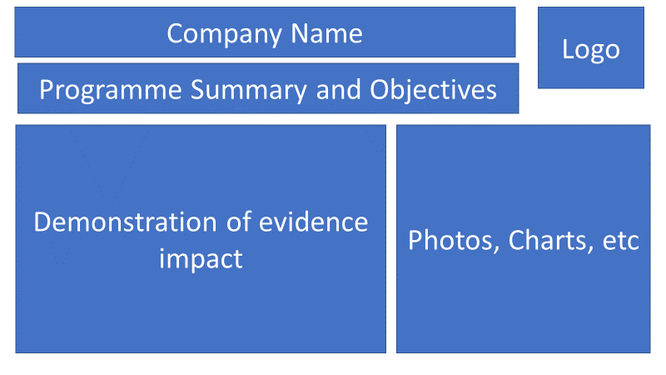

Why the Sustainable Finance Excellence Award?
Sustainability and sustainable finance are increasingly shaping the future of business, innovation, and long-term economic resilience.
As an international bank with a global network across Asia, Africa, and the Middle East, Standard Chartered believes sustainable growth should create lasting positive impact for clients, communities, and wider economy. Through responsible finance, innovation, and cross-border collaboration, we are committed to supporting the transition towards a more sustainable and resilient future.
The Sustainable Finance Excellence Award recognizes organisations that demonstrate leadership, innovation, and measurable impact through sustainability-related initiatives, products, services, financing solutions, or business transformation efforts.
This award celebrates organisations that are driving meaningful and measurable progress towards a more sustainable future.

Judging Process
Applications will be evaluated by an independent panel of judges and assessed based on the following key areas:
- Strategic integration of sustainability and sustainable finance
- Innovation and sustainable business leadership
- Demonstrated environmental and/or social impact
- Governance, accountability, and responsible business practices
- Scalability and long-term sustainability
The panel will shortlist three finalists, and one winner will be announced at the BCCTaipei Better Business Awards Ceremony on 9th September 2026.

How to Submit
Organisations can submit up to two pieces of supporting evidence, explicitly referred to or linked within the main application.
Submissions may include hyperlinks (within the word limit) and must focus on activities that occurred within the 24 months preceding the award deadline.
Email your application to BBAMarketing@bcctaipei.com by Friday, 17 July 2026.

