BCCTaipei Better Business Awards
Innovation for Wellbeing Awards
2025 Guidance and Criteria

Please provide any supporting documents as separate attachments when you send this application in.
Please answer the criteria in the space provided in English or Chinese
Company Name (English/Chinese):
Company Website:
Contact Person:
▪ Name:
▪ Email:
▪ Phone Number:
Judging Criteria
1. Provide a concise summary of the innovation, detailing its objectives and the impact on wellbeing. Highlight key features and benefits. (Limit to 500 words)
2. Submit quantitative and qualitative evidence demonstrating the positive impact of the innovation on people's wellbeing. Emphasise outcomes and measurable impacts rather than activities. (Limit to 1000 words)
3. Provide evidence how the innovation is sustainable in the long-term internally within your organisation and externally in the broader community. Discuss its ongoing impact and potential to grow in scale. (Limit to 600 words)
4. Describe how the innovation is communicated to and engaged with your stakeholder network. Focus on the effectiveness and creativity of communication strategies. (Limit to 500 words)
5. Provide a one-page PowerPoint slide summarising your innovation for wellbeing, highlighting key aspects, objectives, and impacts. 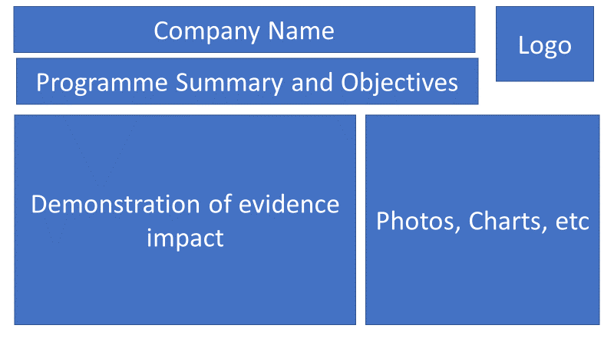
6. Describe any collaborations or partnerships that were integral to the development and implementation of your innovation. Explain how these relationships contributed to the success and impact of the project. (Limit to 500 words)

Why the Innovation for Wellbeing Award?

As a leading insurer, PCA Life Assurance’s mission is to be the most trusted partner and protector for this generation and generations to come, by providing simple and accessible financial and health solutions. The Innovation for Wellbeing Award aligns with our mission and aims to recognise efforts to enhance people's lives by focusing on the following criteria:
Focus on Wellbeing: The issues addressed should relate to health and/or wealth.
Public Interest: Solutions should ideally serve the public interest or assist vulnerable groups, not just employees.
Innovation: This award honours companies that develop innovative solutions, including new products, platforms, and services, to improve health, wealth, wellbeing, and sustainability in Taiwan.
Accessibility: Solutions should be easy to access, affordable for target users, appealing to stakeholders, and providing actionable tools/platforms for active utilisation.
This award is open to companies of all sizes, both local and foreign. It considers not only the innovation project but also how it integrates into the business and benefits recipients, employees, and a wider network of stakeholders.

Judging Process
Entries will be evaluated by our Judging Panel, composed of leading experts in their fields, based on the following criteria:
Concise Summary: A brief summary of the company/individual, including objectives and impact.
Business Story: A concise outline of the business story, highlighting achievements.
Relevant Initiatives: Clearly visible initiatives that are relevant to the selected awards category.
Impact Evidence: Evidence of how these initiatives have transformed your organisation and beyond.

The judging panel will shortlist three companies from all entrants. From these, the panel will select a winning company to be announced at the Award Event on 17th September 2025.
Key Areas of Evaluation for the Innovation for Wellbeing Award
The Judges will look for applications demonstrating success in the following areas:
1. Evaluation of Objectives and Impact
- The connection between the innovation and the company’s business.
- Initiatives align with the goal of innovation for wellbeing, aiming to improve wellbeing and help people live healthier and happier lives.
- Demonstration of both short-term and long-term impacts.
2. Quantitative and Qualitative Evidence
- The benefits of the initiative to the industry, the company, community, and stakeholders.
- Evidence of the innovation being effectively employed.
- Inclusion of robust quantitative and qualitative evidence.
3. Sustainability of the Programme
- Evidence that the programme can be replicated or scaled up.
- Evidence of the long-term sustainability of the programme, both externally and internally, and its impact.
4. Communication and Innovation
- How the innovation is communicated throughout the company’s stakeholder network.
- Effective communication of its impact in accessible and creative ways.

How to Submit
Organisations can submit up to two pieces of supporting evidence, explicitly referred to or linked within the submission. Evidence can be attached to the submission form or emailed along with it.
Submissions may include hyperlinks to internal or external websites within the word limit if relevant.
The content of the submission and evidence should cover activities that have taken place within the 24 months preceding the award deadline.
Email your application to BBAMarketing@bcctaipei.com by Sunday, 17 August 2025.

