BCCTaipei Better Business Awards
Climate Champion
2025 Guidance and Criteria

Please provide any supporting documents as separate attachments when you send this application in.
Please answer the criteria in the space provided in English or Chinese
Company Name (English/Chinese):
Company Website:
Contact Person:
▪ Name:
▪ Email:
▪ Phone Number:
Judging Criteria
- Describe the initiatives your company has undertaken to reduce its carbon footprint. This may include innovations, applications, products, services, or processes. (Limit to 200 words)
- What measurable results have been achieved as a result of these initiatives? Provide specific data or examples. (Limit to 200 words)
- Explain how your company has raised stakeholder awareness on climate action, such as through participation in trade associations, research institutions, or industry groups, and how it has influenced its supply chains. (Limit to 200 words)
- What outcomes have been realized from these efforts in terms of stakeholder engagement and supply chain influence? Provide specific examples or data. (Limit to 200 words)
- Does your company have an environmental strategy, and how is it integrated within your overall business strategy and governance structure? Is it addressed at the board level? (Limit to 200 words)
- Is your company a member of any of the following climate initiatives: Race to Zero, EV100, RE100, Powering Past Coal Alliance (PPCA), or does it follow the Task Force on Climate-Related Financial Disclosures (TCFD) recommendations?

Please select all that apply: None / Race to Zero / EV100 / RE100 / PPCA / TCFD
- Has your company received any awards or recognition for its climate action efforts? If so, please describe the achievements that led to this recognition. (Limit to 200 words)
- Provide a one-page PowerPoint slide summarizing your climate action initiatives and results. (See template below)
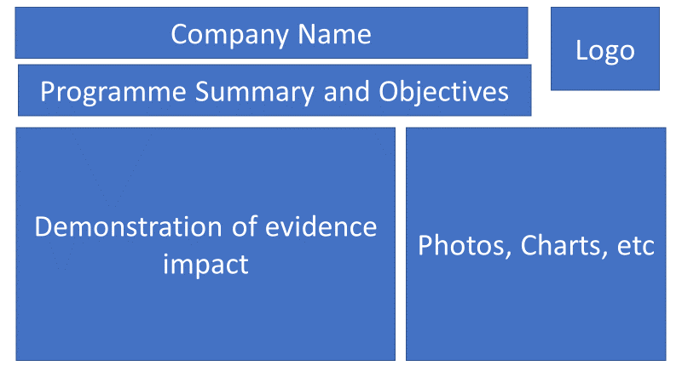
Why the Climate Champion Award?
The BCCTaipei Better Business Climate Champion Award will recognise a company operating in Taiwan that has made significant strides in reducing its carbon footprint and demonstrated leadership in climate action.
The science is unequivocal: to limit global temperature rise to 1.5°C, we must achieve net zero emissions by 2050 at the latest. We are seeking companies that have implemented effective measures to reduce emissions and actively contribute to this global goal.
The UK is a global leader in climate action, and we aim to spotlight a company in Taiwan that has shown similar leadership during the 2022-2023 period. We are looking for companies that have integrated climate action into all facets of their business operations. This includes raising awareness among stakeholders, collaborating with supply chains and partners to reduce their carbon footprints, elevating climate action to the board level, and participating in specific climate-related initiatives.
This award, sponsored by Eiger Law, is the first of its kind. It provides a unique opportunity to highlight your company’s climate leadership. The winner will be selected by our judging panel and promoted through the British Chamber of Commerce in Taipei as the Better Business Awards 2025 Climate Champion.
We encourage companies of all sizes, British and non-British, operating in Taiwan to apply.
Judging Process
Companies will be evaluated based on their performance, including any ongoing projects in Taiwan from December 2023 to December 2024. Submissions and evidence must cover activities within this timeframe.
We are looking for specific actions that companies have taken towards:
- Reducing their carbon footprint
- Acting as a climate leader
How to Submit
Applications should include clear evidence of the impact of these actions. Submissions will be assessed by a panel consisting of Eiger Law staff and independent business leaders.
Submissions may include hyperlinks to internal or external websites within the word limit if relevant.
The content of the submission and evidence should cover activities that have taken place within the 24 months preceding the award deadline.
Email your application to BBAMarketing@bcctaipei.com by Sunday, 17 August 2025.

