BCCTaipei Better Business Awards
Sustainability Award
2025 Guidance and Criteria

Please provide any supporting documents as separate attachments when you send this application in.
Please answer the criteria in the space provided in English or Chinese
Company Name (English/Chinese):
Company Website:
Contact Person:
▪ Name:
▪ Email:
▪ Phone Number:
Judging Criteria
1. Long-Term Sustainability Strategy
Describe how your company ensures the long-term impact and continuity of your sustainability efforts. Include any strategies, systems, or commitments that demonstrate how sustainability is embedded into your ongoing operations.
(Limit to 600 words)
2. Innovative Sustainability Initiatives
Highlight at least two innovative sustainability initiatives, programmes, or services implemented for employees, customers, partners, or the wider community. Describe the objectives, outcomes, and how these initiatives contribute to long-term sustainability goals.
(Limit to 1000 words)
3. Stakeholder Engagement and Communication
Explain how your sustainability efforts are communicated to internal and external stakeholders in clear, accessible, and engaging ways. Emphasise measurable results and impact rather than just activities.
(Limit to 500 words)
4. Integration into Business Mission
Provide examples of how sustainability is embedded in your company’s mission, values, and daily operations. Show how these efforts go beyond traditional CSR and are aligned with your core business strategies.
(Limit to 500 words)
5. Evidence of Impact
Provide both quantitative and qualitative data that demonstrate the environmental, social, and/or economic impact of your sustainability initiatives. Focus on measurable outcomes and long-term benefits for the targeted communities or ecosystems.
(Limit to 1000 words)
6. Sustainability Programme Summary Slide
Please submit a one-page PowerPoint slide summarising the objectives and key focus areas of your Sustainability Programme. This slide will be used for presentation purposes.
(See template provided)
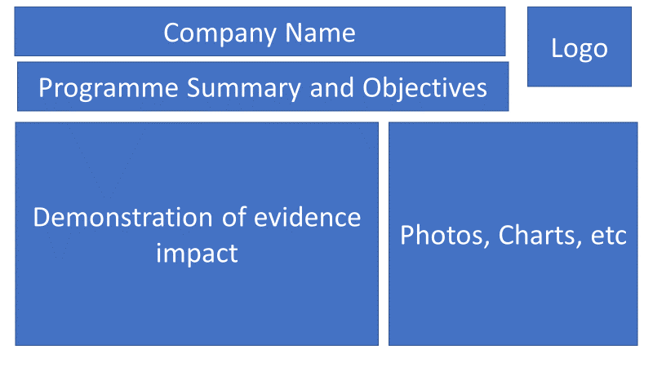

Why the Sustainability Award?
Sustainability — also known as Corporate Social Responsibility (CSR), ESG, or Responsible Business — has evolved into a cornerstone of long-term business resilience and purpose. Once viewed primarily as philanthropic effort, it now represents a company’s commitment to future-proofing operations, building stakeholder trust, and actively contributing to the planet’s wellbeing.
Today, employees, investors, and consumers increasingly expect businesses to take a proactive role in addressing climate change, resource use, and social impact. A strong sustainability strategy is not only a driver of brand value and competitive advantage — it’s a vital element in attracting top talent, building meaningful partnerships, and creating long-term, scalable impact.
The Sustainability Award recognises a company operating in Taiwan that demonstrates excellence, innovation, and integration in its sustainability journey. This includes not only standalone initiatives, but also how sustainability is embedded into business strategy, operational processes, and decision-making frameworks. We are especially interested in organisations that show tangible outcomes for people, communities, ecosystems, and supply chains.
This year, the award is proudly sponsored by Cadeler, a key player in the offshore wind industry and a strong advocate for the global energy transition. Cadeler delivers offshore wind installation solutions that support the world’s shift toward decarbonisation. With a commitment to innovation, safety, and environmental stewardship, Cadeler partners with industry leaders to build a cleaner and more resilient energy future. Their sponsorship reflects the importance of engineering sustainability into every level of business — from strategy to execution.
We welcome submissions from companies of all sizes and across all industries. Whether you're enabling low-carbon technologies, building circular systems, or empowering communities through sustainable practices, this is your opportunity to share your leadership and impact.

Judging Process
Applications will be evaluated by an independent panel of experts and assessed based on the following key areas:
- Mission & Strategic Integration – Clarity of vision and how sustainability is built into the business
- Impact Evaluation – Demonstrated environmental, social, and/or economic outcomes
- Sustainability of the Programme – Scalability, resilience, and long-term commitment
- Communication & Innovation – How initiatives are communicated and the originality in design or delivery
The panel will shortlist three finalists, and one winner will be announced at the BCCTaipei Better Business Awards Ceremony on 17 September 2025.

How to Submit
Organisations can submit up to two pieces of supporting evidence, explicitly referred to or linked within the main application.
Submissions may include hyperlinks (within the word limit) and must focus on activities that occurred within the 24 months preceding the award deadline.
Email your application to BBAMarketing@bcctaipei.com by Sunday, 17 August 2025.

